Sofware Architectural Design Requirements

A two-wheels robot needs to be designed that roll and detects obstacles and void in front of it.

This document lists the requirements of the sofware architectural design.

Every requirement is composed of :

* One unique ID following this pattern : ADR_XXXX (Four digits)
* A name, which is always a small introduction of the requirement
* A text, describing what is the requirement for.

This is the schematic of the system :

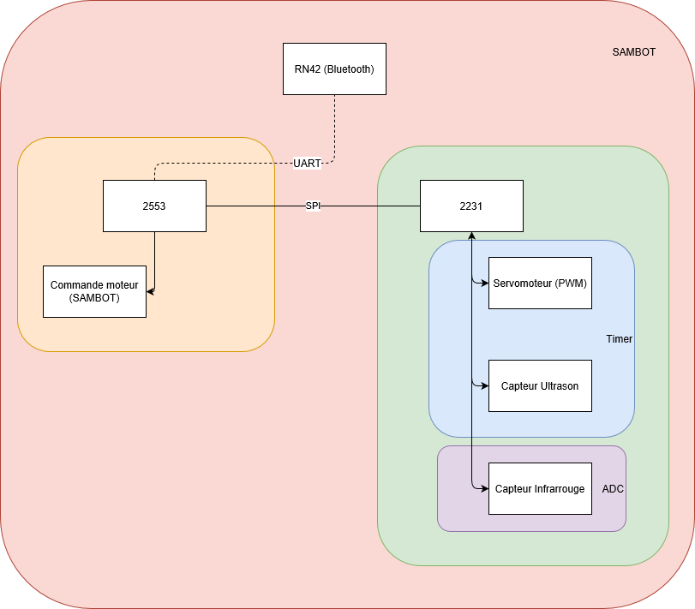

**ADR_0100**

Name : Roll

Text : The robot shall roll in a reasonable speed.

Covers :

Module :

**ADR_0200**

Name : Obstacle detection

Text : The robot shall detect obstacles in front of it with an ultrasound sensor and avoid them.   
Covers :

Module :

**ADR_0300**

Name : ultrasound sensor

Text : The sensor will be placed on a servomoteur that will move within 180° area

**ADR_0400**

Name : Void detection

Text : The robot shall detect void in front of it with an infrared sensor and avoid it

Covers :

Module :

**ADR_0500**

Name : Manual mode

Text : The user shall control the robot by sending commands to it with the MSP2553 via UART connection

Covers :

Module :

**ADR_0600**

Name : Autonomous mode

Text : the robot shall be able to manage itself without the intervention of the user

Covers :

Module

**ADR_0700**

Name : Communication

Text : The robot shall communicate with the user via Bluetooth connection

Covers :

Module :

**ADR_0800**

Name : Structure

Text : the robot shall have two processors :

MSP2553, which controls robot’s motors (direction) and sends the commands to the second processor

MSP2231, which receives the commands via SPI connection and handles the servomoteur and the two sensors (ultrasound and infrared)

**ADR_0900**

Name : Turn around

Text : the robot shall be able to turn around left or right and run backward.  
Covers :

Module :

**ADR_1000**

Name : infrared sensor

Text : the infrared sensor will be placed at the edge of the robot in order to detect the void early

Covers

Module :